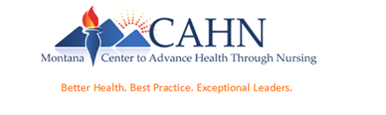
Help Advance Health through Nursing Leadership for Montana’s Rural Nurses!
As part of a Doctor of Nursing Practice (DNP) quality improvement scholarly project through Gonzaga University & the Montana Center to Advance Health through Nursing (MT CAHN) I would like to invite Nurse Managers working in Montana’s critical access hospitals (CAH) to participate in a
FREE online leadership educational program!
32 FREE contact hours available through the Montanan CAHN
for those who enroll & complete the educational program!

Who: Nurse Managers (Director of Nursing [DON], Assistant DON, Chief Nursing Officer [CNO], & Charge Nurses [LPNs and RNs])
What: FREE, evidenced-based nursing leadership education program (including healthcare financing) that is for nurses everywhere!
Where: Online – with support from the MT CAHN Leadership Council (on your schedule, over an 8-week period)
When: October 2018 – December 2018
Why: To assess this new leadership training program for nurses in rural Montana.
How: Simply enroll in this 8-week program by clicking on this link: https://docs.google.com/forms/d/e/1FAIpQLSdy4dkQJMl4_l2a7pQdAkPUbthxc0ExWVb6RU2jmL6TE44K8A/viewform
Next:
1. You will be sent a brief survey to complete before the course opens,
2. You will participate in a brief informational webinar to answer any of your questions
3. The program course link will be sent to you,
4. You will have weekly support from online webinar as you need,
5. Each week, complete 1 module (about 2 – 4 hours/week; this is ‘asynchronous’ – meaning, you do this on your own schedule!),
6. Cut-and-paste & save your posttests from each module and email your scores each week/when a module is completed - to Michele Sare, the project investigator
7. When all 8 modules are completed, complete a satisfaction survey and a short leadership perception survey.
8. You are asked to complete the 8-module leadership education program by 12/10/2018.
In Spring 2019 – all data will be analyzed, and the project summary will be shared with you by April 2019.
Confidential/Risk/Benefits: All participant information will be private/confidential. There is no compensation or risk for participating. Enrollment is optional, and participants may withdraw at any time.
Thank you so very much! We look forward to working with and learning from you!

Michele Sare, MSN, RN
Gonzaga University DNP Student
msare@zagmail.gonzaga.edu

https://mtcahn.org/

